APP1 name: Owaves

URL: <http://owaves.com/>

**Description:** Owaves is a wellness planner app, users can make better plans and be more concentrated on accomplishing their goals. It helps people to focus on health and wellness objectives. The main user interface looks like a dart board, users are able to make their wellness plans for a day, a week, or a month, and they can review their previous wellness plans either. The icons on the first graph represent love, exercise, work, eat, sleep, relax, play and flow. Users can change the time period of each activity by altering the length of the relevant activities. Also, they can save their preferred routines, so next time when they want to change back the previous routines, they don’t need to reset again. Also, users can share their wellness plans to their friends by most of the social softwares.

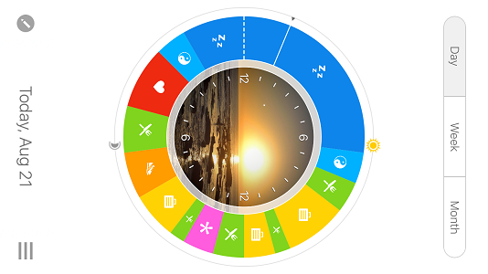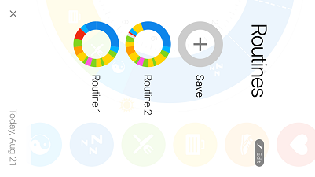

**Positive aspects：**

Design (interactivity)

The user interface design is interesting and clean, it simply divides the different time periods of each day into different parts which can be showed on a disk. Also, the design makes it comfortable for uses to use, in other word, it is very user friendly. All the function parts of the application is clear. So, on our application, we can think of other design plans to make it more attractive.

Functionality perspectives

The functionality perspectives of the application are suitable for making wellness plans, it can make users’ life more methodical, as the function is user friendly, they can arrange their wellness plans well by this application. Based on this, our application functions need to meet all the customers’ need and it should be convenient to use.

**Negative aspects**

Features

The features of this application is actually not that competitive, as most similar wellness application will have the similar features. At the same time, there are too few contents inside the application, it is not attractive for users to play, it is a basic wellness planning app. In case of this, we should add more contents to our own application, and try to make our application attractive.

**Design guidelines**

Provide filter and sort options

Be responsive with visual feedback after significant actions

APP2 name: Rise

URL: <https://www.rise.us/>

Description: Rise is a customized diet application. It focuses on providing customers the most professional advice on dieting, especially helping people lose weight and build up a healthy body. It believes that there is no one-size fits all solution, when users start to use this application, the system will allocate some most suitable coaches for them based on the questionnaires and their personal details they submitted. As the first picture below shows, users need to answer some basic questions, so that the system can find their personal coaches as the second picture shows below, they can view the coaches’ experiences and personal information and then decide which one is suitable for themselves. At last, they need to give detailed personal information, like real name, contact number, and their weight. Then, submit, and the coach they choose will contact them and give suitable and professional advice for them to keep on diet.

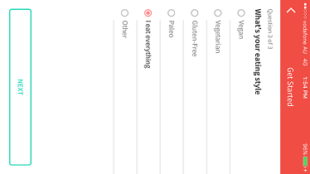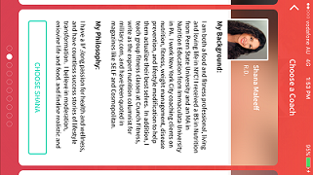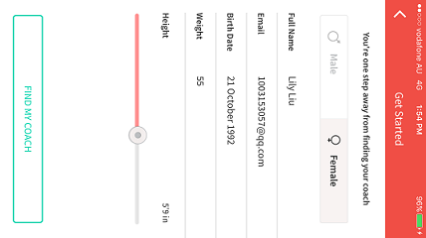

**Positive aspects**

Features

This application has its special functionality, as it does not give dieting suggestions themselves, instead, it provides professional coaches to guide the users. This will definitely improve users’ training results, because users will be guided properly, just need to pay a little money compared with becoming a gym member every month,and they can enjoy professional service. Also, this app plays a third party role, to manage the cooperation between users and coaches, users benefits can be guaranteed as well.

**Negative aspects**

Design(interactivity**)**

The user interface design is not pleasing, as it starts with a series of questions and the patterns and layout are not interesting at all, which makes it unfriendly for users to use.

Functionality aspects

The functionalities of this application are quite basic and simple, there are not many practical functions exist.

Design guidelines：

Organize and label menu categories to be user-friendly

App3 Name: Sworkit

URL: <https://play.google.com/store/apps/details?id=sworkitapp.sworkit.com>

Description: Sworkit is a personalized exercise application. It allows you to customize and play personalized video workouts. On the first page,There are various training videos, users can choose the suitable exercising activity and how much time they want to do for the specific exercise, then just follow the instructions of those short videos. There will also be a timer when you start doing the exercise, as it showed on the first picture, so users can manage their exercise precisely and easily. Then, after they finish each task, the workout they have done will be presented, so, they can manage their training more reasonable. In addition, users are able to share their achievements by social media, for example, Facebook and Twitter. So, users can have more fun by competing with their friends.

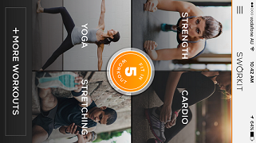 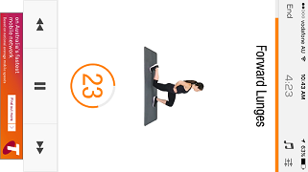

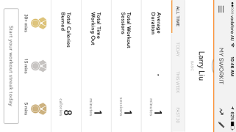

**Positive aspects**

Design(interactivity**)**

The whole design of this application is actually not bad. All the function parts are divided clearly, and the arrangement is suitable. The user interface is attractive as well. Also, this application provides users with training videos, compared with other form of guide, this is more direct and clear, and users can better understand the detail of the workout. In addition, this application is easy to get into it, as the guide through the application is quite clear. Compared to our application, organized structure and clean layout can be used.

Features

This application is unique, because it uses videos to guide workout process, which is quite suitable for this kind of application. Users can also choose their preferred exercise type and time, this will give users more flexibility. Based on this, we should give more flexibility to users in our app, so they won’t get upset by those limitations.

**Negative aspects**

Functionality aspects

This application is designed to guide people how to exercise properly and do workouts the way they like, but there are not many unique functionality parts exist. So, in our app, we need to add more functionality aspects to make users get interested.

**Design guideline**

Keep it brief

Decide for me but let me have the final say